INDIAN INSTITUTE OF TECHNOLOGY, KHARAGPUR



RELIABILITY TESTING LABORATORY
RE69003

Subir Chowdhury School of Quality and Reliability
Autumn (2025 – 2026)

LT CDR ARAVIND MANIKANDAN (25RE61D01)
KADIMI TARUN (25RE61R05)
SUTAMA SARKAR (25RE61R07)
ACKNOWLEDGEMENT

1. We would like to express our deepest gratitude to the Head of the Department - Prof. Neeraj Kumar Goyal, whose expert guidance and insightful teachings in Reliability Engineering have been invaluable throughout this laboratory work. His continuous encouragement and rigorous academic inputs have significantly enhanced our understanding and skills on the subject. We are truly thankful for his mentorship and the time he devoted to helping us strengthen our analytical and practical abilities in this domain.

2. We are also sincerely grateful to Prof. Sanjay Kumar Chaturvedi and Prof. Heeralal Gargama for their valuable insights through academic sessions on the subject “Reliability Estimation and Life Testing”. Their guidance have played a crucial role in shaping our learning experience.

3. We extend our heartfelt gratitude to Mr. Tanmay Mondal, our lab-in-charge, for his consistent assistance, smooth coordination of lab activities, and technical support.

4. Finally, we thank all our seniors and fellow students for their cooperation, collaborative learning spirit, and mutual support throughout the lab work, which made this journey both productive and enriching.

INDEX

Para No | Paragraph Title | Page No
1 | Aim | 4
2 | Introduction | 4
3 | Applications of Electromechanical Relays | 4
4 | Construction | 4
5 | Specification of Relay Under Test | 5
6 | Operating Conditions | 5
7 | Experimental Setup | 5
8 | Experimental Procedure | 6
9 | Test Results | 8
10 | Distribution Fitting of the Failure Times using Least Square Estimation (LSE) Method | 10
11 | Determination of Acceleration Factor Graphically | 20
12 | Reliability & Failure Probability Curves at Normal Use Temperature | 23
13 | Inferences | 25
14 | Conclusion | 25
15 | Recommendations | 25

RELAY LAB EXPERIMENT

- Aim. To conduct accelerated life testing on relays to estimate reliability using different estimation methods.

- Introduction.

2.1. Electromechanical relays consist of a coil, an armature, a set of contacts, and a spring.

2.2. When an electrical current flows through the coil, it creates a magnetic field that attracts the armature, causing the contacts to close or open.

2.3. This mechanical action allows relays to control high-power circuits with a low-power input signal.

2.4. In order to estimate the reliability of relays, a sample of 10 relays were selected for accelerated life testing at three different (130⁰C, 110⁰C and 90⁰C) temperatures.

2.5. The time to failures of relays were recorded. Arrhenius model was selected as accelerated life model and data is analysed using Minitab software as well as manual calculation.

3. Applications of Electromechanical Relays. The following are some of the critical applications of Electromechanical Relays:-

3.1. Power System Protection. Used in overcurrent, overvoltage, undervoltage, distance, and earth fault protection.

3.2. Control Systems & Automation. Used in control panels for: Starter circuits, safety alarms.

3.3. Home Appliances. Refrigerators, washing machines, microwave ovens use relays for switching compressors, heaters, and motors.

3.4. Timing & Sequential Control. When combined with timers, relays create sequence control for: Packaging machines, Elevators.

4. Construction.

4.1. The contacts of the relays are metallic surfaces that open or close when the armature moves.

4.2. These contacts are positioned to either complete or interrupt the electrical circuit in response to the movement of the armature.

4.3. The relay has one common terminal and two contacts in two different configurations (normally open and normally closed).

4.4. The relay switches between two circuits, when there is no voltage applied to the coil, one circuit is closed and the other one is open. When the coil is de-energized the opposite happens.

5. Specification of Relay Under Test.

5.1. Type: Electromechanical Power Relay

5.2. Model: JQC-3FC (T73)

5.3. Coil Type: DC Coil

5.4. Rated Coil Voltage: 12 V DC

5.5. Operating Frequency: 50/60 Hz (for AC switched loads)

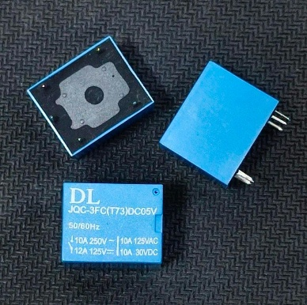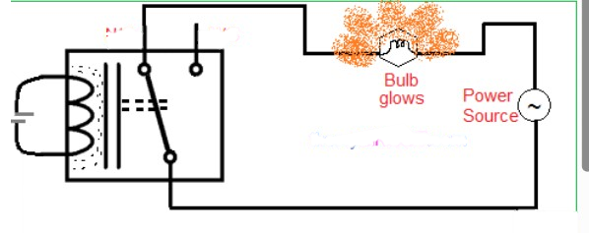
Fig 1 – SPDT Relay

6. Operating Condition.

  - Testing Profile: 1A 12V at 130ºC(403K), 120ºC (383K), 90ºC (363K).

6.2. Switching: 4 cycles per minute (01 cycle = 5s ON & 10s OFF).

7. Experimental Setup.

7.1. The setup consists of 10 relays, 10 bulbs, 10 LEDs and 100 W load. 12V DC voltage is supplied to coil for excitation.

7.2. The relays are kept in a temperature chamber for providing the test temperatures.

7.3. Relays, bulbs and LEDs are connected as per the circuit diagram.

7.4. Connecting wires are properly sieved with insulator to protect it from high temperature.

7.5. The relay is considered fail when the designated bulb glows and failure time is recorded.

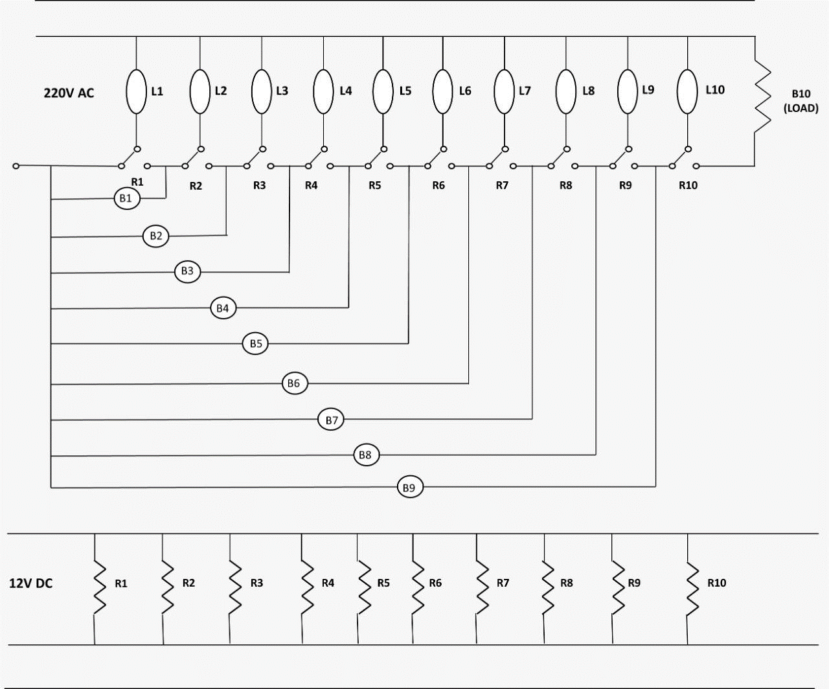
Fig 2 - Circuit Diagram

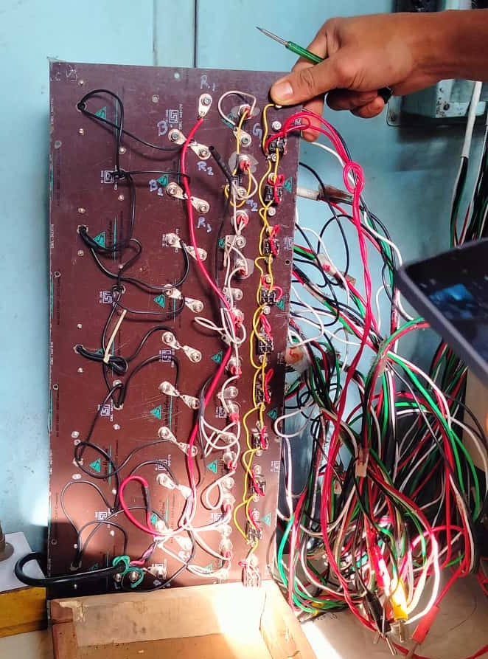
Fig 3 – Relay Main Circuit Board

8. Experimental Procedure.

8.1. Check and confirm all the equipment are properly connected as per the circuit diagram.

8.2. Check all meters for calibration.

8.3. Three samples of Relays were randomly taken up for the test. Each sample comprised 10 Relays (all of same make, model and batch). Relays are kept in the temperature chamber for exposure to test temperatures.

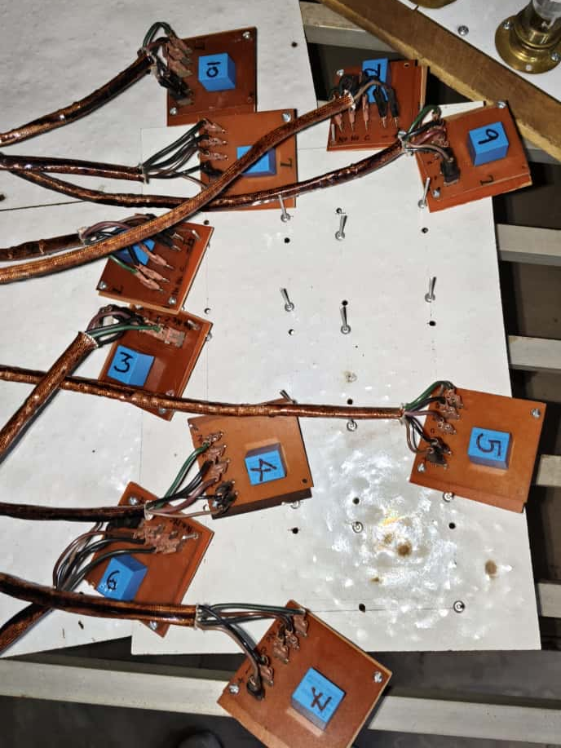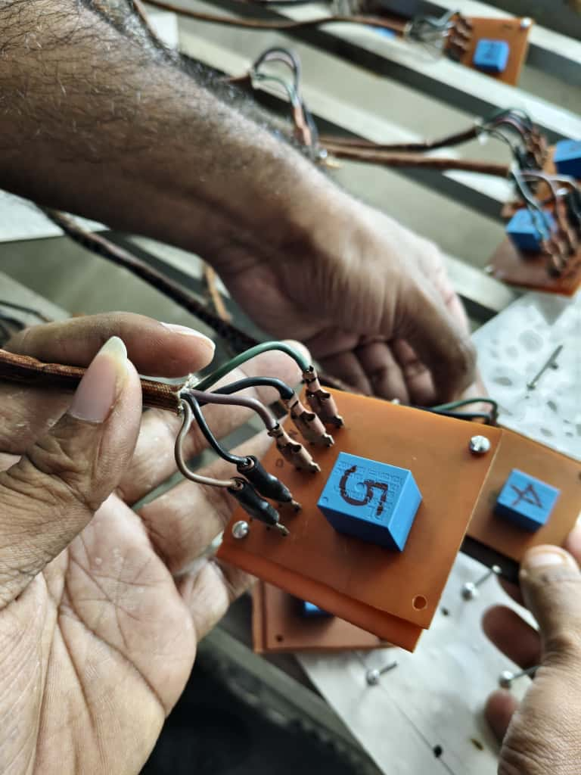
Fig 4 – Preparation of Test Set Up

8.4. Switch on the temperature chamber. Check whether the test temperature is maintained properly in the test chamber.

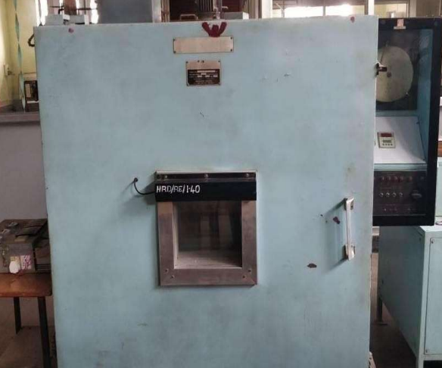
Fig 5 – Thermal Chamber

8.5. Switch on both main power supply and 12 V DC for excitation.

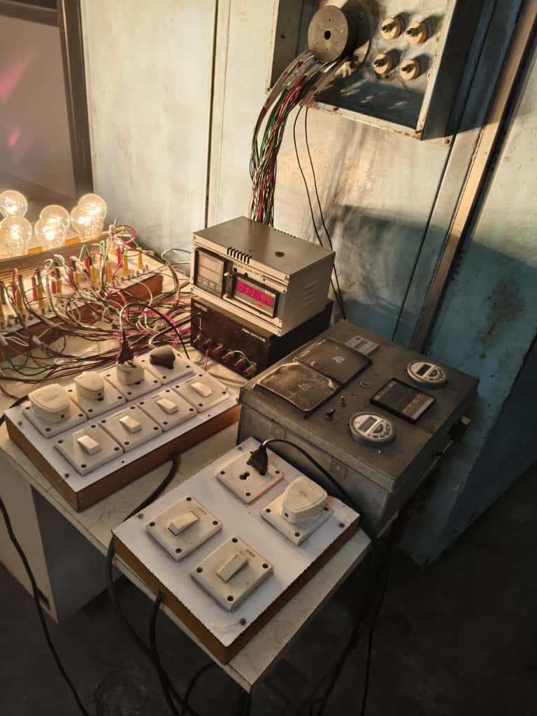
Fig 6 – Test Set Up – AC-DC Power Supply and Timer Circuit

8.6. Note the reading of the counter when any of the relay experiences a failure.

9. Test results. Failures of Relays are observed at temperatures 130°C (403K), 120°C (393K), 90°C (363K) and the same are tabulated as below:-

9.1. Test data at 130°C.

Table 7.1 – Test data at 130°C (403K)

Relay Number | Failure times (cycles) | ti (accelerated condition) (hr) | Failure mode
R2 | 2724 | 11.350 | Short Circuit
R9 | 3324 | 13.850 | Short Circuit
R6 | 3765 | 15.688 | Short Circuit
R5 | 4457 | 18.571 | Short Circuit
R10 | 5433 | 22.638 | Short Circuit
R1 | 6088 | 25.367 | Short Circuit
R3 | 6822 | 28.425 | Short Circuit
R4 | 7699 | 32.079 | Short Circuit
R8 | 8250 | 34.375 | Short Circuit
R7 | 8542 | 35.592 | Short Circuit

9.2. Test data at 120°C.

Table 7.2 – Test data at 120°C (393K)

Relay Number | Failure times (cycles) | ti (accelerated condition) (hr) | Failure mode
R2 | 3022 | 12.59 | Short Circuit
R10 | 3627 | 15.11 | Short Circuit
R4 | 4956 | 20.65 | Short Circuit
R7 | 5416 | 22.57 | Short Circuit
R3 | 6612 | 27.55 | Short Circuit
R1 | 7210 | 30.04 | Short Circuit
R5 | 8342 | 34.76 | Short Circuit
R8 | 9076 | 37.82 | Short Circuit
R6 | 10549 | 43.95 | Short Circuit
R9 | 11351 | 47.30 | Short Circuit

9.3. Test data at 90°C.

Table 7.3 – Test data at 90°C (363K)

Relay Number | Failure times (cycles) | ti (accelerated condition) (hr) | Failure mode
R1 | 5568 | 23.20 | Short Circuit
R9 | 7123 | 29.68 | Short Circuit
R4 | 8476 | 35.32 | Short Circuit
R6 | 9920 | 41.33 | Short Circuit
R8 | 11042 | 46.01 | Short Circuit
R3 | 12457 | 51.90 | Short Circuit
R2 | 13843 | 57.68 | Short Circuit
R7 | 15321 | 63.84 | Short Circuit
R5 | 16455 | 68.56 | Short Circuit
R10 | 17863 | 74.43 | Short Circuit

10. Distribution Fitting of the Failure Times using Least Square Estimation (LSE) Method. LSE of the three failure data set was carried out through MS Excel and the relevant plots are attached below:-

10.1. LSE of Failures Observed at 403K. It can be observed from the below figures that the coefficient of correlation is higher and closest to 1 for Weibull distribution. This indicates that the failures observed at 403K can be best described through Weibull distribution.

Fig 7 – Probability Plots for Failure (cycles) Data iro 403K

10.2. LSE of Failures Observed at 393K. It can be observed from the below figures that the coefficient of correlation is higher and closest to 1 for Weibull distribution. This indicates that the failures observed at 393K can be best described through Weibull distribution.

Fig 8 – Probability Plots for Failure (cycles) Data iro 393K

10.3. LSE of Failures Observed at 363K. It can be observed from the below figures that the coefficient of correlation is higher and closest to 1 for Weibull distribution. This indicates that the failures observed at 363K can be best described through Weibull distribution.

Fig 9 – Probability Plots for Failure (cycles) Data iro 363K

10.4. Weibull Distribution Parameters for Failures at different Temperatures.

Table 7.4 – Shape and Scale Parameter for Test Temperatures

Temperature  (in K) | Shape Parameter | Scale Parameter  (in cycles)
403 | 2.734 | 6456.62
393 | 2.499 | 7967.12
363 | 2.917 | 13289.61

10.5. F(ti) vs ti (in hrs) Curve. With the values of parameters as determined above, F(ti) values for different values of time, are calculated and Failure CDF curves for different Temperatures are generated as below:-

Table 7.5 – F(ti) for Test Temperatures

ti (in hrs) | F(ti) - 403K | F(ti) - 393K | F(ti) - 363K
0 | 0 | 0 | 0
1 | 0.000123269 | 0.00015803 | 8.2212E-06
2 | 0.00081982 | 0.000893005 | 6.2091E-05
3 | 0.002481937 | 0.002457909 | 0.00020261
4 | 0.005441623 | 0.005037624 | 0.00046886
5 | 0.009992766 | 0.008781851 | 0.00089875
6 | 0.016396877 | 0.013815183 | 0.00152923
7 | 0.024883898 | 0.020241426 | 0.00239644
8 | 0.035650838 | 0.028145646 | 0.00353575
9 | 0.048859332 | 0.037595123 | 0.00498171
10 | 0.064632743 | 0.048639767 | 0.00676804
11 | 0.08305321 | 0.061312262 | 0.00892757
12 | 0.104158958 | 0.075628103 | 0.01149214
13 | 0.127942132 | 0.091585639 | 0.0144925
14 | 0.154347371 | 0.109166175 | 0.01795822
15 | 0.183271327 | 0.128334192 | 0.02191753
16 | 0.214563259 | 0.149037723 | 0.02639725
17 | 0.248026813 | 0.171208898 | 0.03142259
18 | 0.283423048 | 0.194764678 | 0.03701705
19 | 0.320474697 | 0.219607783 | 0.04320226
20 | 0.358871613 | 0.245627816 | 0.04999784
21 | 0.398277285 | 0.272702571 | 0.05742125
22 | 0.438336242 | 0.300699514 | 0.06548764
23 | 0.478682128 | 0.329477419 | 0.07420973
24 | 0.518946196 | 0.358888129 | 0.08359765
25 | 0.558765901 | 0.388778428 | 0.09365882
26 | 0.597793307 | 0.418991975 | 0.10439787
27 | 0.63570299 | 0.449371277 | 0.11581646
28 | 0.67219914 | 0.479759662 | 0.12791327
29 | 0.707021614 | 0.510003221 | 0.14068384
30 | 0.739950717 | 0.539952672 | 0.15412058
31 | 0.770810563 | 0.56946512 | 0.16821268
32 | 0.799470933 | 0.598405684 | 0.18294611
33 | 0.825847606 | 0.62664895 | 0.19830361
34 | 0.849901227 | 0.654080241 | 0.21426472
35 | 0.871634828 | 0.680596664 | 0.23080579
36 | 0.891090189 | 0.706107949 | 0.24790008
37 | 0.908343252 | 0.730537031 | 0.26551786
38 | 0.923498848 | 0.753820415 | 0.28362649
39 | 0.93668501 | 0.775908285 | 0.30219057
40 | 0.948047122 | 0.796764402 | 0.32117215
41 | 0.957742179 | 0.816365771 | 0.34053085
42 | 0.965933351 | 0.834702122 | 0.36022412
43 | 0.97278506 | 0.851775202 | 0.38020744
44 | 0.97845868 | 0.867597925 | 0.40043463
45 | 0.983108979 | 0.882193386 | 0.42085802
46 | 0.986881316 | 0.895593785 | 0.44142886
47 | 0.989909611 | 0.907839276 | 0.46209751
48 | 0.992315038 | 0.918976778 | 0.48281381
49 | 0.994205378 | 0.929058773 | 0.50352738
50 | 0.995674946 | 0.938142112 | 0.52418796
51 | 0.996804968 | 0.946286862 | 0.5447457
52 | 0.997664336 | 0.953555209 | 0.56515151
53 | 0.998310603 | 0.960010428 | 0.58535736
54 | 0.998791145 | 0.965715951 | 0.6053166
55 | 0.999144394 | 0.970734524 | 0.62498426
56 | 0.999401085 | 0.975127473 | 0.64431729
57 | 0.999585442 | 0.978954081 | 0.6632749
58 | 0.999716293 | 0.982271068 | 0.68181872
59 | 0.999808065 | 0.985132188 | 0.69991308
60 | 0.999871655 | 0.987587917 | 0.71752517
61 | 0.999915184 | 0.989685247 | 0.73462522
62 | 0.999944615 | 0.991467563 | 0.75118662
63 | 0.999964268 | 0.992974598 | 0.76718606
64 | 0.999977228 | 0.99424246 | 0.78260356
65 | 0.999985666 | 0.995303716 | 0.79742256
66 | 0.999991089 | 0.99618752 | 0.81162989
67 | 0.99999453 | 0.996919788 | 0.82521578
68 | 0.999996685 | 0.997523388 | 0.8381738
69 | 0.999998017 | 0.998018364 | 0.85050077
70 | 0.999998829 | 0.998422159 | 0.86219668
71 | 0.999999318 | 0.998749854 | 0.87326455
72 | 0.999999608 | 0.9990144 | 0.88371026
73 | 0.999999777 | 0.999226842 | 0.89354239
74 | 0.999999875 | 0.99939654 | 0.90277203
75 | 0.999999931 | 0.999531374 | 0.91141257
76 | 0.999999963 | 0.999637934 | 0.91947948
77 | 0.99999998 | 0.999721698 | 0.92699009
78 | 0.999999989 | 0.999787186 | 0.93396335
79 | 0.999999994 | 0.999838109 | 0.94041959
80 | 0.999999997 | 0.999877491 | 0.94638029
81 | 0.999999999 | 0.99990778 | 0.95186785
82 | 0.999999999 | 0.999930948 | 0.95690538
83 | 1 | 0.99994857 | 0.96151644
84 | 1 | 0.999961901 | 0.96572488
85 | 1 | 0.999971928 | 0.96955459
86 | 1 | 0.999979428 | 0.97302938
87 | 1 | 0.999985007 | 0.97617277
88 | 1 | 0.999989133 | 0.97900783
89 | 1 | 0.999992166 | 0.98155709
90 | 1 | 0.999994385 | 0.98384238
91 | 1 | 0.999995997 | 0.98588476
92 | 1 | 0.999997163 | 0.9877044
93 | 1 | 0.999998 | 0.98932054
94 | 1 | 0.999998598 | 0.99075144
95 | 1 | 0.999999023 | 0.99201432
96 | 1 | 0.999999323 | 0.99312536
97 | 1 | 0.999999534 | 0.99409968
98 | 1 | 0.999999681 | 0.99495134
99 | 1 | 0.999999783 | 0.99569335
100 | 1 | 0.999999853 | 0.9963377

Fig 10 – Failure CDF Plot at different Test Temperatures

10.6. R(ti) vs ti Curve. With the values of parameters as determined above, R(ti) values for different values of time, are calculated and Reliability curves for different Temperature are generated as below:-

Table 7.6 – R(ti) for Test Temperatures

ti (in hrs) | R(ti) - 403K | R(ti) - 393K | R(ti) - 363K
0 | 1 | 1 | 1
1 | 0.99987673 | 0.99984197 | 0.99999178
2 | 0.99918018 | 0.99910699 | 0.99993791
3 | 0.99751806 | 0.99754209 | 0.99979739
4 | 0.99455838 | 0.99496238 | 0.99953114
5 | 0.99000723 | 0.99121815 | 0.99910125
6 | 0.98360312 | 0.98618482 | 0.99847077
7 | 0.9751161 | 0.97975857 | 0.99760356
8 | 0.96434916 | 0.97185435 | 0.99646425
9 | 0.95114067 | 0.96240488 | 0.99501829
10 | 0.93536726 | 0.95136023 | 0.99323196
11 | 0.91694679 | 0.93868774 | 0.99107243
12 | 0.89584104 | 0.9243719 | 0.98850786
13 | 0.87205787 | 0.90841436 | 0.9855075
14 | 0.84565263 | 0.89083383 | 0.98204178
15 | 0.81672867 | 0.87166581 | 0.97808247
16 | 0.78543674 | 0.85096228 | 0.97360275
17 | 0.75197319 | 0.8287911 | 0.96857741
18 | 0.71657695 | 0.80523532 | 0.96298295
19 | 0.6795253 | 0.78039222 | 0.95679774
20 | 0.64112839 | 0.75437218 | 0.95000216
21 | 0.60172271 | 0.72729743 | 0.94257875
22 | 0.56166376 | 0.69930049 | 0.93451236
23 | 0.52131787 | 0.67052258 | 0.92579027
24 | 0.4810538 | 0.64111187 | 0.91640235
25 | 0.4412341 | 0.61122157 | 0.90634118
26 | 0.40220669 | 0.58100802 | 0.89560213
27 | 0.36429701 | 0.55062872 | 0.88418354
28 | 0.32780086 | 0.52024034 | 0.87208673
29 | 0.29297839 | 0.48999678 | 0.85931616
30 | 0.26004928 | 0.46004733 | 0.84587942
31 | 0.22918944 | 0.43053488 | 0.83178732
32 | 0.20052907 | 0.40159432 | 0.81705389
33 | 0.17415239 | 0.37335105 | 0.80169639
34 | 0.15009877 | 0.34591976 | 0.78573528
35 | 0.12836517 | 0.31940334 | 0.76919421
36 | 0.10890981 | 0.29389205 | 0.75209992
37 | 0.09165675 | 0.26946297 | 0.73448214
38 | 0.07650115 | 0.24617959 | 0.71637351
39 | 0.06331499 | 0.22409171 | 0.69780943
40 | 0.05195288 | 0.2032356 | 0.67882785
41 | 0.04225782 | 0.18363423 | 0.65946915
42 | 0.03406665 | 0.16529788 | 0.63977588
43 | 0.02721494 | 0.1482248 | 0.61979256
44 | 0.02154132 | 0.13240208 | 0.59956537
45 | 0.01689102 | 0.11780661 | 0.57914198
46 | 0.01311868 | 0.10440622 | 0.55857114
47 | 0.01009039 | 0.09216072 | 0.53790249
48 | 0.00768496 | 0.08102322 | 0.51718619
49 | 0.00579462 | 0.07094123 | 0.49647262
50 | 0.00432505 | 0.06185789 | 0.47581204
51 | 0.00319503 | 0.05371314 | 0.4552543
52 | 0.00233566 | 0.04644479 | 0.43484849
53 | 0.0016894 | 0.03998957 | 0.41464264
54 | 0.00120886 | 0.03428405 | 0.3946834
55 | 0.00085561 | 0.02926548 | 0.37501574
56 | 0.00059891 | 0.02487253 | 0.35568271
57 | 0.00041456 | 0.02104592 | 0.3367251
58 | 0.00028371 | 0.01772893 | 0.31818128
59 | 0.00019194 | 0.01486781 | 0.30008692
60 | 0.00012834 | 0.01241208 | 0.28247483
61 | 8.4816E-05 | 0.01031475 | 0.26537478
62 | 5.5385E-05 | 0.00853244 | 0.24881338
63 | 3.5732E-05 | 0.0070254 | 0.23281394
64 | 2.2772E-05 | 0.00575754 | 0.21739644
65 | 1.4334E-05 | 0.00469628 | 0.20257744
66 | 8.9109E-06 | 0.00381248 | 0.18837011
67 | 5.4697E-06 | 0.00308021 | 0.17478422
68 | 3.3148E-06 | 0.00247661 | 0.1618262
69 | 1.983E-06 | 0.00198164 | 0.14949923
70 | 1.1709E-06 | 0.00157784 | 0.13780332
71 | 6.823E-07 | 0.00125015 | 0.12673545
72 | 3.9231E-07 | 0.0009856 | 0.11628974
73 | 2.2255E-07 | 0.00077316 | 0.10645761
74 | 1.2454E-07 | 0.00060346 | 0.09722797
75 | 6.8739E-08 | 0.00046863 | 0.08858743
76 | 3.7417E-08 | 0.00036207 | 0.08052052
77 | 2.0083E-08 | 0.0002783 | 0.07300991
78 | 1.0628E-08 | 0.00021281 | 0.06603665
79 | 5.5444E-09 | 0.00016189 | 0.05958041
80 | 2.8509E-09 | 0.00012251 | 0.05361971
81 | 1.4447E-09 | 9.222E-05 | 0.04813215
82 | 7.2143E-10 | 6.9052E-05 | 0.04309462
83 | 3.5494E-10 | 5.143E-05 | 0.03848356
84 | 1.7204E-10 | 3.8099E-05 | 0.03427512
85 | 8.2134E-11 | 2.8072E-05 | 0.03044541
86 | 3.862E-11 | 2.0572E-05 | 0.02697062
87 | 1.7882E-11 | 1.4993E-05 | 0.02382723
88 | 8.1527E-12 | 1.0867E-05 | 0.02099217
89 | 3.6592E-12 | 7.8336E-06 | 0.01844291
90 | 1.6167E-12 | 5.6154E-06 | 0.01615762
91 | 7.0299E-13 | 4.0029E-06 | 0.01411524
92 | 3.0087E-13 | 2.8374E-06 | 0.0122956
93 | 1.2668E-13 | 1.9999E-06 | 0.01067946
94 | 5.2514E-14 | 1.4017E-06 | 0.00924856
95 | 2.1427E-14 | 9.7677E-07 | 0.00798568
96 | 8.5487E-15 | 6.7677E-07 | 0.00687464
97 | 3.3307E-15 | 4.6621E-07 | 0.00590032
98 | 0 | 3.193E-07 | 0.00504866
99 | 0 | 2.1742E-07 | 0.00430665
100 | 0 | 1.4718E-07 | 0.0036623

Fig 11 – Reliability Plot at different Test Temperatures

11. Determination of Acceleration Factor Graphically. Since the Shape Parameter values vary for each experiment, an average value of the same is assumed for further calculation. Subsequently, Acceleration Factors were calculated and normal use temperatures were determined.

11.1. Averaging of Shape Parameter.
β_{average} = (β_{403K} + β_{393K} + β_{363K})/3 = 2.717

11.2. Calculation of revised Scale Parameter (in hrs) and Mean Time To Failure (in hrs) with Average Shape Parameter value. Revised Scale Parameter is calculated using Maximum Likelihood Equation:-

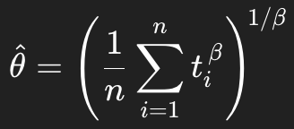

The MTTF values are calculated using formula:-



The revised θ and MTTF values are tabulated below:-

Table 7.7 – Revised Parameter Values for Test Temperatures

Temperature  (in K) | Shape Parameter | Scale Parameter  (in cycles) | Mean Time to Failure  (in cycles)
403 | 2.717 | 6260 | 5568
393 | 2.717 | 7818 | 6954
363 | 2.717 | 12824 | 11407

11.3. Plotting of ln (θ) vs Stress (1/T). The values obtained above are plotted in MS Excel to observe the Arrhenius model equation and values of A, B are calculated from the straight line equation as shown below.

Fig 12 – Arrhenius Plot of ln(θ) vs Stress (1/T)

ln(θ) = ln A + B/T
ln A = 2.4286
A = 11.34
B = E_{a}/K = 2555

Activation Energy = E_{a} = 2555 x 8.617 * 10⁻⁵ = 0.2201eV

As per the Original Equipment Manufacturer’s specifications, the subject SPDT Relay will operate upto 10 million operations (mechanical cycles) under normal usage.

11.4. Acceleration Factors (AFs). AFs are calculated as below and the normal use life of Relays observed in above three experiments are as below:-

AF_{t→u} = θ(use)/θ(test)
AF₄₀₃₋₂₉₈ = 10000000 / 6260 = 1597.44
AF₃₉₃₋₂₉₈ = 10000000 / 7818 = 1279.09
AF₃₆₃₋₂₉₈ = 10000000 / 12824 = 779.79

11.5. Test data at 130°C to normal use condition using AF = 1597.44.

Table 7.8 – Life at Normal Use Condition as Extrapolated from 130°C (403K)

Relay Number | ti (accelerated condition) (cycles) | ti (normal use condition) (cycles)
R2 | 2724 | 4351427
R9 | 3324 | 5309891
R6 | 3765 | 6014362
R5 | 4457 | 7119790
R10 | 5433 | 8678892
R1 | 6088 | 9725215
R3 | 6822 | 10897736
R4 | 7699 | 12298691
R8 | 8250 | 13178880
R7 | 8542 | 13645332

11.6. Test data at 120°C to normal use condition using AF = 1279.09.

Table 7.9 – Life at Normal Use Condition as Extrapolated from 120°C (393K)

Relay Number | ti (accelerated condition) (cycles) | ti (normal use condition) (cycles)
R2 | 3022 | 3865410
R10 | 3627 | 4639259
R4 | 4956 | 6339170
R7 | 5416 | 6927551
R3 | 6612 | 8457343
R1 | 7210 | 9222238
R5 | 8342 | 10670169
R8 | 9076 | 11609021
R6 | 10549 | 13493120
R9 | 11351 | 14518951

11.7. Test data at 90°C to normal use condition using AF = 779.79.

Table 7.10 – Life at Normal Use Condition as Extrapolated from 90°C (363K)

Relay Number | ti (accelerated condition) (cycles) | ti (normal use condition) (cycles)
R1 | 5568 | 4341871
R9 | 7123 | 5554444
R4 | 8476 | 6609500
R6 | 9920 | 7735517
R8 | 11042 | 8610441
R3 | 12457 | 9713844
R2 | 13843 | 10794633
R7 | 15321 | 11947163
R5 | 16455 | 12831444
R10 | 17863 | 13929389

12. Reliability & Failure Probability Curves at Normal Use Temperature.

12.1. The normal use Cycles To Failures of 30 Relays (as determined above) are arranged in an ascending sequence and using Lease Square Estimation method, the distribution which fits this data the best is determined to be Normal Distribution. Fitting of the data in LSEs are as below.

Fig 13 – Probability Plots for Cumulative Failure (cycles) Data

13. Inferences.

13.1. The cumulative failure data follows a Normal distribution, confirming it as a suitable model for relay lifetime analysis.

13.2. The mean value estimated from the Normal distribution LSE indicates a mean life of 8746333 cycles which is close to OEM established life of 10 million cycles .

13.3. The scale parameter (θ) of accelerated life failures increases with decreasing temperature, demonstrating that relay life improves significantly at lower thermal stress.

13.4. The Arrhenius plot of ln(θ) vs 1/T produced a clear linear trend, validating the use of Arrhenius modelling for thermal acceleration of relay failures.

14. Conclusion. The analysis provides a preliminary understanding of the reliability of the relays under high-temperature conditions and high switching cycles. Key findings include:

14.1. Temperature & Switching Cycles Sensitivity. Elevated temperatures and switching cycles significantly impact relay life, as demonstrated by high acceleration factors, indicating that maintaining lower operational temperatures and low switching rate is crucial for optimal relay lifespan.

14.2. The mean life of the subject Relays estimated at normal-use condition is approximately 8746333 cycles.

14.3. Short-circuit failures were consistently observed, indicating contact wear as the dominant failure mechanisms under the accelerated stress profile.

14.4. The study confirms that temperature, switching rate, and electrical load collectively govern relay life, highlighting the importance of proper derating and operating conditions in practical applications.

15. Recommendations. In view of the above, the following are recommended to obtain better test results for future studies:-

15.1. The switching frequency may be adjusted to reflect realistic field conditions so that the observed degradation corresponds to genuine wear-out mechanisms rather than overstress failures.

15.2. Accurate calibration and uniform temperature control of the thermal chamber must be ensured to avoid localized overheating and improve the consistency of the results.

15.3. Additionally, larger sample sizes and wider temperature spacing may be considered to achieve more reliable Arrhenius fitting.

